UIW Joining Circles of Interfaith Service for “Affordable Housing, Homelessness, and Gentrification”
UIW faculty and students are invited to gather ideas for service in light of this “Religious Leadership and Civic Engagement” initiative https://wagner.nyu.edu/leadership/research/projects/public# and soon a strategic plan for united efforts will be developed.
Archbishop Gustavo Siller and Sister Martha Ann Kirk, director of the UIW Interfaith Innovation Grant, were among twenty-three faith leaders from San Antonio: mainline and evangelical Christians, Roman Catholics, Muslims, Jews, and Sikhs, all of whom put their heads together, broke bread at TriPoint, and earnestly debated which important issues should be chosen for collaborative efforts in service to the city on February 8, 2018.
The group decided to take on Affordable Housing, Homelessness, and Gentrification. All of our faiths are steeped in callings to make certain we take care of the homeless and insure that every family lives in a secure dwelling, safe from harm, both by weather or unkind human beings.
This group first gathered at the invitation of Rabbi Samuel Stahl of San Antonio and Rabbi Steve Gutow from New York City who is part of the Religious Leadership and Civic Engagement Project at NYU.
Sister Martha Ann Kirk shared that as she did research in the Sisters Archives in light of the Tricentennial of San Antonio she discovered heart-warming examples. October 30, 1912 when a terrible fire burned St. John’s Orphanage, the Incarnate Word Sisters were able to get over 90 little boys out of the fire, but five of them burned to death and 3 boys that they could not find.
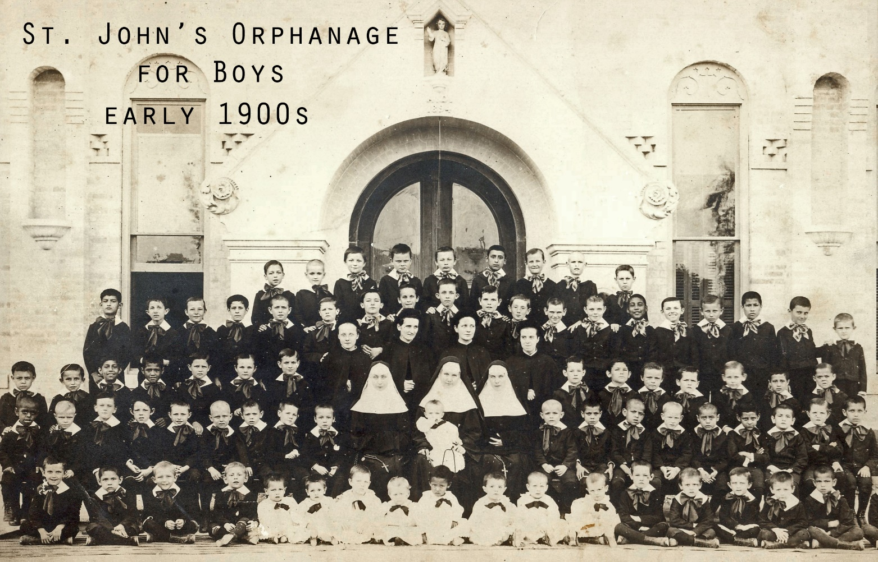
She found a San Antonio newspaper report after the fire that mentions the Jewish children of Temple Beth El School giving money to help the orphans and the children of the Protestant Orphanage also donating. Obviously the faith community had compassion that bridged over differences and instilled values of service in the next generation.
The national goals of Religious Leadership and Civic Engagement project can be found on their website with more resources:
“Mobilize faith communities to address common concerns
Break through barriers of understanding and identity, finding paths to work together
Equip religious leaders with advocacy and organizing skills to influence policies and standards of key concern to their constituents and wider society
To assist community advocates who have a deep and profound calling for service rooted in the religious identity to organize and effect real change within their community”
From https://wagner.nyu.edu/leadership/research/projects/public#
Rabbi Stahl and Rabbi Gutow wrote to the participants after the gathering, “You are an amazing group of people! It was clear to both of us that God’s spirit filled our conversation. Our Holy One mandated us to be partners in helping to create the world that we deeply believe God wants, and that is our calling.”
UIW persons who would like to be involved are invited to contact Sister Martha Ann Kirk kirk@uiwtx.edu

